**Project description**

**Members**

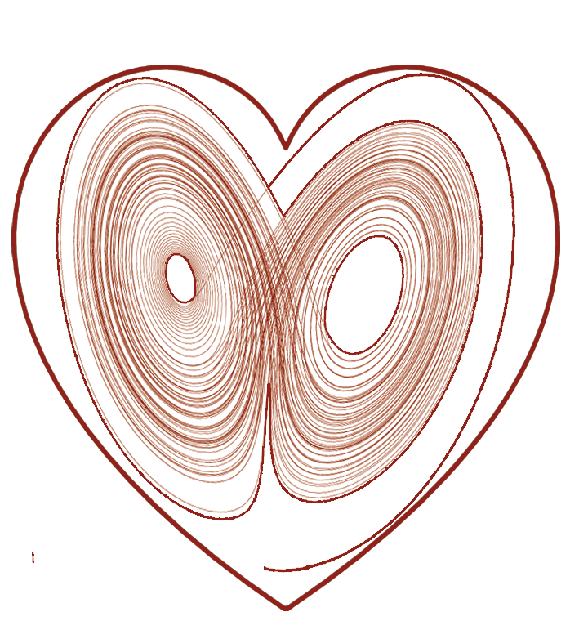

|  |  |
| --- | --- |
| István Széplaki | Signal processing / data analysis |
| 정기현 | Smartphone app development |
| Raad shariat | Hardware implementation |
| George Muravyov | Business plan / search for funding |
| Artem Lenski | System architect / website development |

**Keywords**

Brain, Health, Connectivity, Gadget, Sensing, Enhancement

**What is innovative or disruptive about our venture?**

We propose a wearable ear gadget, which is equipped with a number of sensors: pulse oximeter, an electrode to measure electromyography associated with eyelids, an electrode to measure electrical activity of the brain along the scalp, and a temperature sensor. The device is equipped with a Bluetooth sensor to communicate with a smart phone and a flash storage. All data processing is done on the phone. There are no ear gadgets on the market. The proposed gadget focuses on analyzing mental activity and sympathetic nervous system that none of gadgets analyze now.

**What is our unique value proposition?**

The uniqueness of the proposed gadget is in the state of the art signal processing algorithms and data analysis. The sympathetic nervous system is analyzed via heart rate variability that is extracted from detected heart beats. Information about physiological stress, biological age and heart problems are assessed from heart rate variability. Electromyography is used to detect eye blinks. The dynamics of inter-blink intervals allows us estimate state of the mind and drowsiness of the person. Coupled together with electrodes help us monitor people’s brain activity.

**What problem(s) are we solving and for whom?**

1. *Elderly people*: by monitoring and analyzing heart activity, congested heart failure, arrhythmia is recognized. By analyzing inter-blink intervals and electrical activity at the electrode, Impending stroke can be detected.
2. *Physically active people*: the proposed algorithms allow us to assess physiological stress, estimate biological age, advice on best time for physical activity.
3. *Students and car drivers*: by analyzing inter-blink activity a state of the mind is assessed as well as degree of drowsiness.

**What is our solution?**

Our solution is a wearable ear gadget that collects data from the sensors and transmits it to the phone. The algorithms running on the phone are analyzing the data and informs user of his/her brain and heart state. The distinguishable features of our project are

1. Small and easy to wear eye gadget, by placing it on the ear, allows us collecting eye activity, brain activity and heart activity
2. Various types of signals are read thus providing more information about the user unlike smart watches with only pulse oximeter.
3. The application makes the data be accessible online

**Who are our customers?**

Elderly people, physically active people, car drivers and those who are involved in learning i.e. students or takers of online classes.

The device is useful for wide spectrum of people including elderly people, people who exercise and generally those who are interested in their health. We have already developed an Android application that estimates biological age using smartphones camera as a pulse oximeter. Many people got excited while assessing their biological age using our app. Now it is time to develop a wearable device which does much more than this.